**How to Create Azure VM (Virtual Machine)**

We can create a windows [virtual machine (VM)](https://azurelessons.com/how-to-reset-password-in-azure-virtual-machine/) in Microsoft Azure for **free** or **How to create a free Azure VM**

Note: To create an[Azure VM](https://azurelessons.com/move-azure-vm-to-a-different-resource-group/) for free, you can [sign up for a 30-days Azure free trial](https://azurelessons.com/create-azure-free-account/).

**How To Create Free Virtual Machine In Azure**

Follow the below steps to create a[virtual machine](https://azurelessons.com/remove-azure-vm/) in Azure.

Here, we will discuss How to Create Azure VM (Virtual Machine) with the new version of Windows Server 2019 Datacenter or how to create a VM in Azure portal step by step.

Make sure you have a subscription to azure before starting. If you don’t have a subscription then

* [create a free Azure account](https://www.youtube.com/watch?v=CKkaEW85uAw).
* [How To Create Azure Windows Virtual Machine From A Snapshot PowerShell](https://azurelessons.com/create-azure-virtual-machine-from-a-snapshot/)
* [Azure Virtual Machine Tutorial](https://azurelessons.com/azure-virtual-machine-tutorial/)
* [How to access Azure VM (Virtual Machine)](https://azurelessons.com/how-to-access-azure-vm/)
* [Azure virtual machine auto shutdown](https://azurelessons.com/azure-vm-auto-shutdown/)

Assuming you have an Azure subscription now. Follow the below steps to create a windows virtual machine.

**Step-1:** Login to [https://portal.azure.com](https://portal.azure.com/).

**Step-2:** Now click on **“Virtual machines”**option from the left side Menu and then click on**“Create”** link.

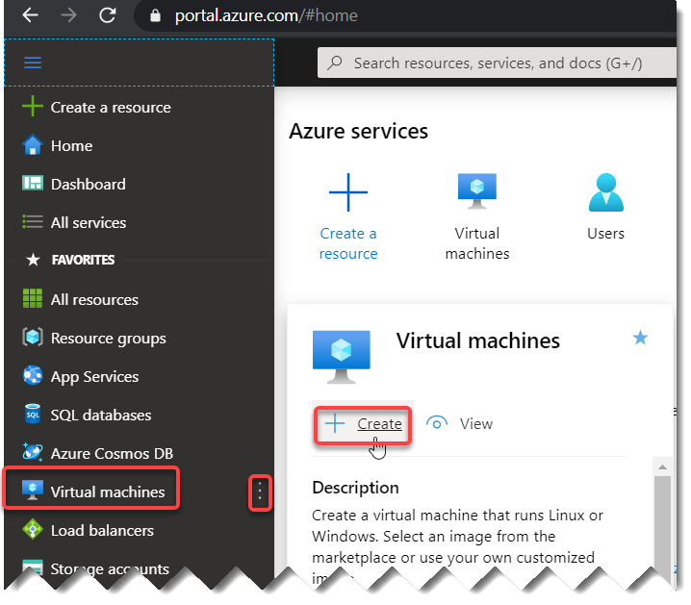

**Or**Go to **“Virtual machines”** option from the **“Azure services”** section.

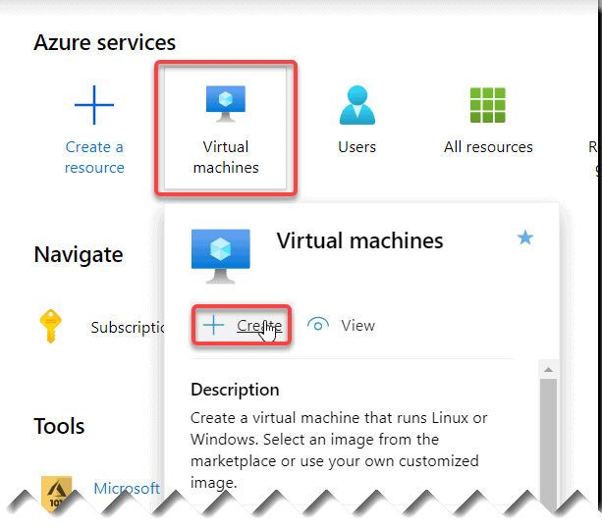how to create virtual machine in windows azure

One more way is to go to the same option fromthe**“Create a resource”** link from the left side menu and then select the**“Compute”** and **“Virtual machine”**.

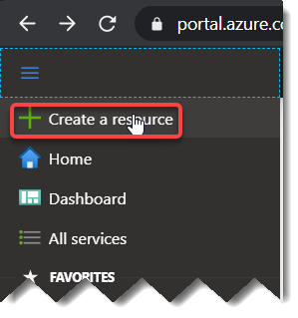

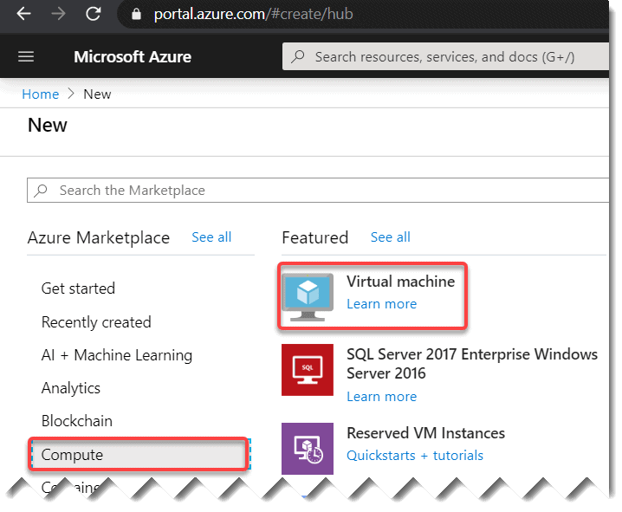virtual machine in azure

Or else for the same option you can go to the**“Create a resource”** link from the **“Azure services”** section and then select the**“Compute”** and **“Virtual machine”**.

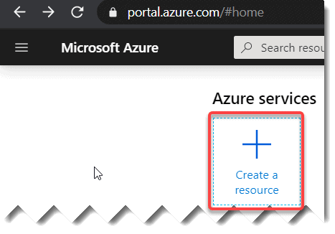

You can see the option “Virtual machine’ like below:



**Step- 3:** Fill the details required. A few of the options you can keep as it is but based on your business need you can change those.

* [Subscription](https://azurelessons.com/you-are-not-eligible-for-an-azure-subscription/): Choose your correct subscription.
* [Resource group](https://azurelessons.com/what-is-resource-group-in-azure/): You can choose the existing resource group or you can create a new one by clicking the “**Create New**” option. It acts like a container that stores the resources related to an Azure solution.
* **Virtual machine name**: Provide a name for your virtual machine.
* **Region**: This the location where you are going to create all the resources related to the virtual machine.
* **Image**: Choose the **Windows Server 2019 Datacenter**. You can change it based on your business need.
* **Size**: The size you want to assign based on your requirement. I have chosen **Standard D2s v3** as per my business requirement.

In the Administrator account section, Choose a **Username, Password** that you will use to login to the VM once created.

**Select Inbound port:**Choose **HTTP(80),RDP(3389)**. This is a very important option.

All other options you can keep as it is. Now click on “**Next:Disks** **>**” button.

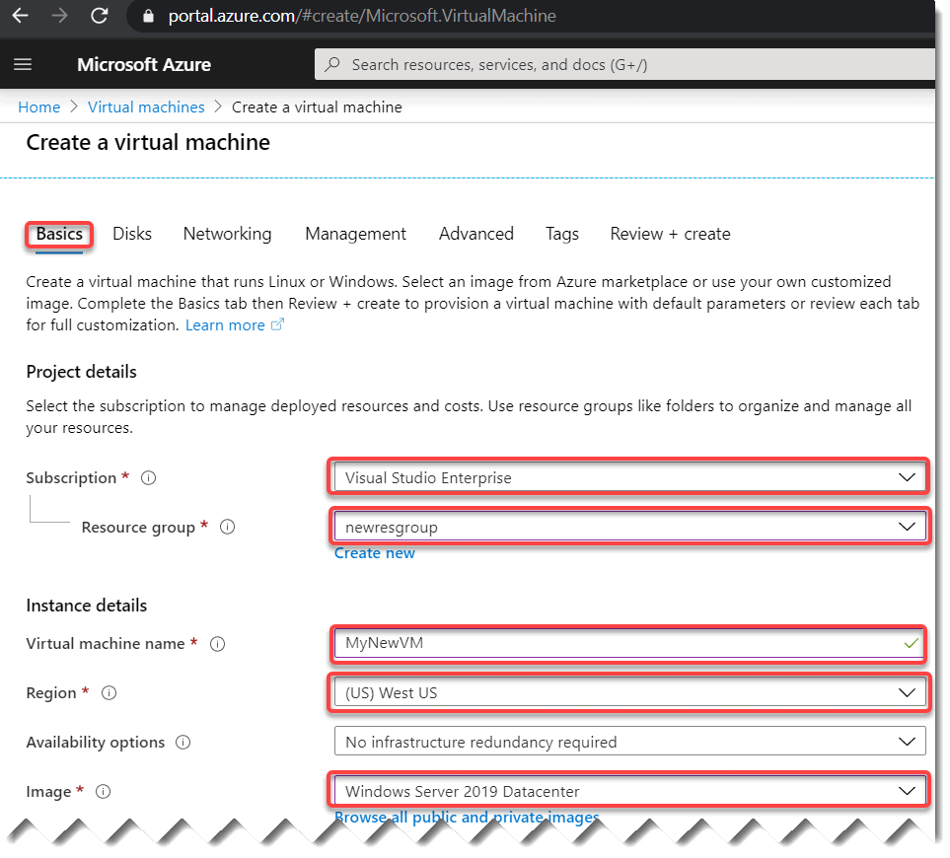

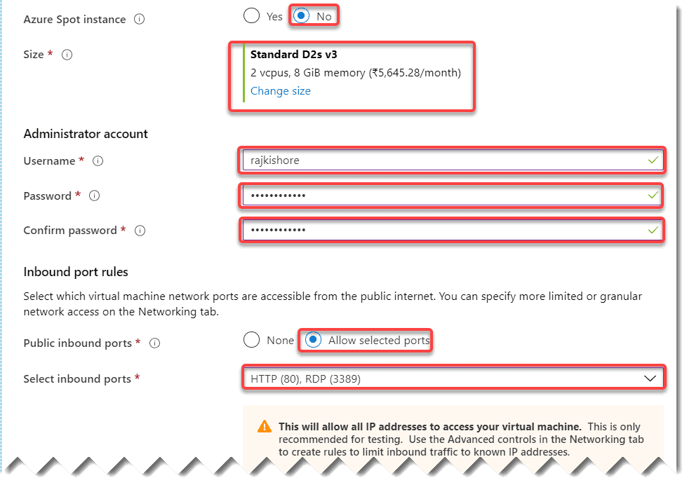

Since, I do not have a windows server license, you can select **No**license.

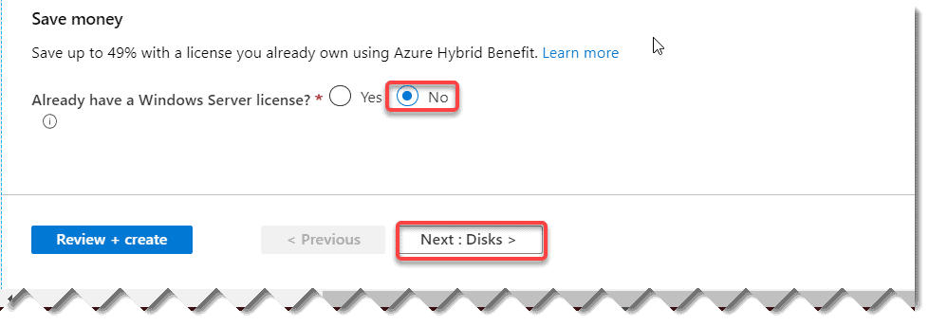

In the next screen**(Disks)**, you can add the disk architecture that you want. I kept the default option as it is. You can change it based on your business need. Click on **Next: Networking** button.

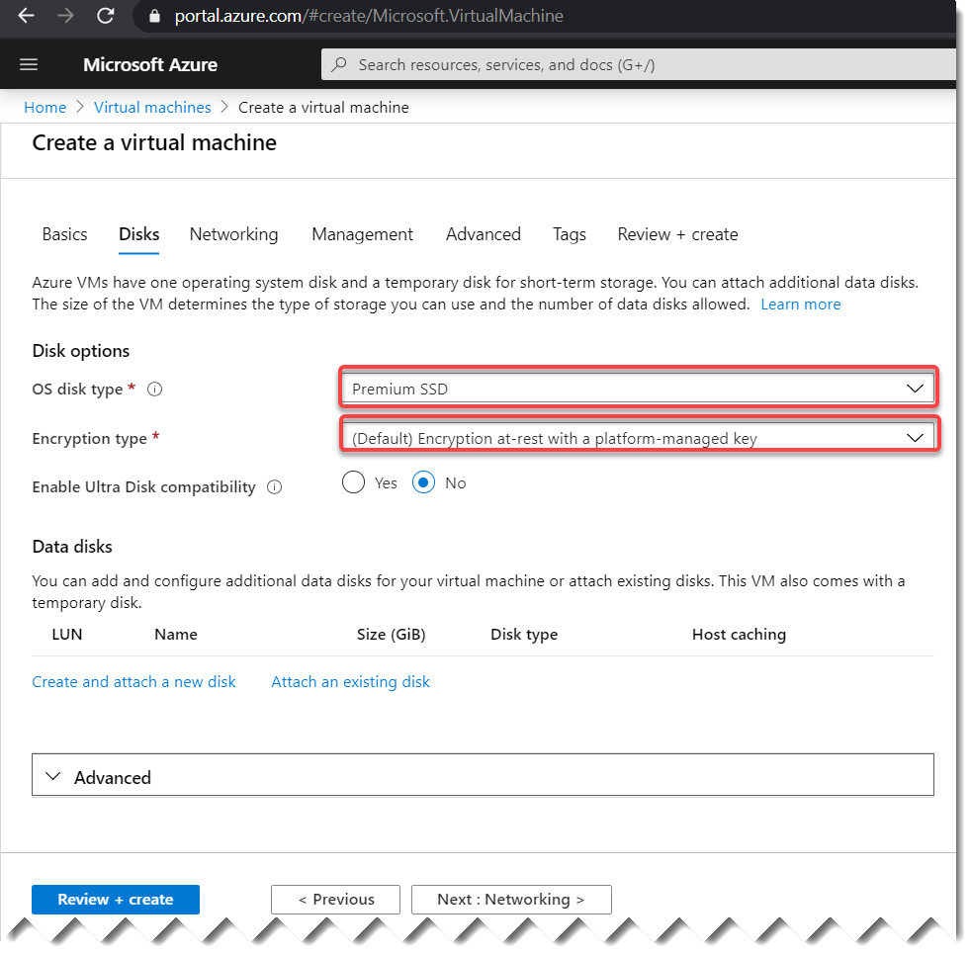

Now you can fill the below details in the Networking screen.

* **Virtual Network**: Choose a **virtual network** or else you can create a new one by clicking the **“Create New”** link.
* **Subnet:** You can keep the default option as it is.
* **Public inbound ports**: choose **Allow selected ports**.
* **Select inbound ports**: This is a very important option. Choose the option as **HTTP(80), RDP(3389)** here. Once you choose this option in the Basics tab it will automatically show the same option here. Keep the option as it is.

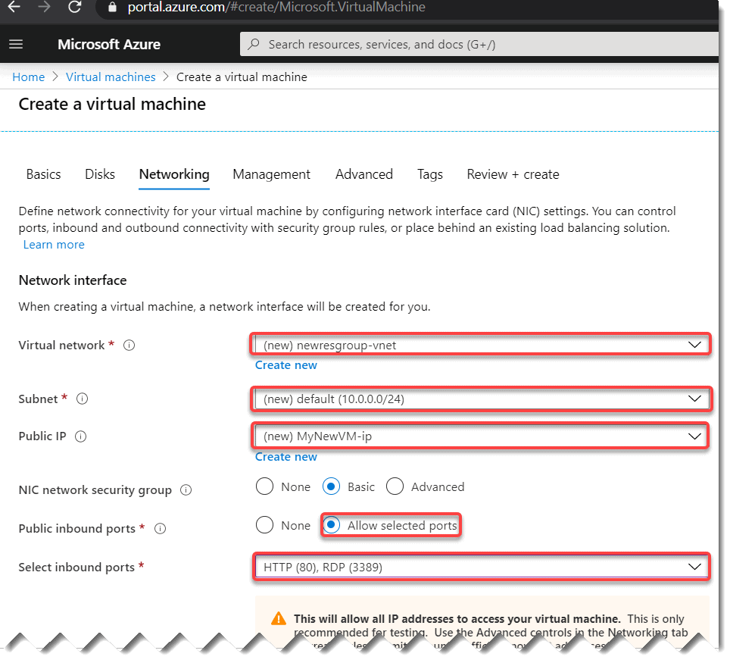

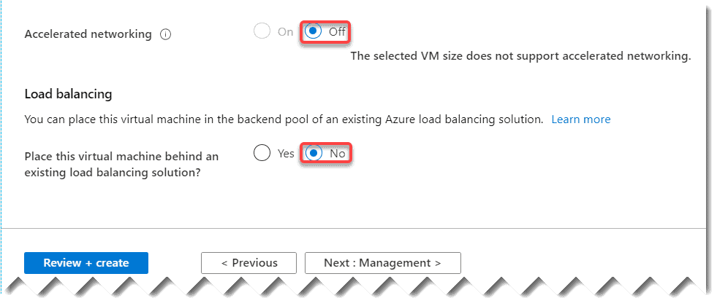

Now for other tabs all the options you can keep as it is. Once you fill all the above details click on the **“Review + Create”** button. Azure will validate the above details internally and will show a message **“Validation passed”**.

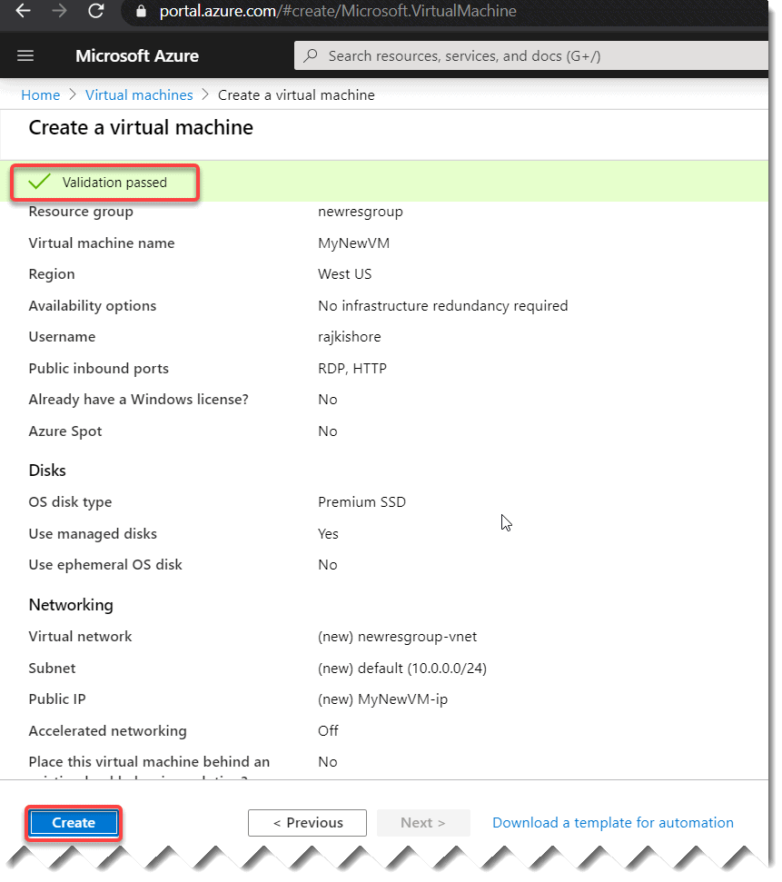

**Step- 4:** Now click on the “**Create**” button. It will show you “**Your deployment is complete**”. Now click on **“Go to resource”**

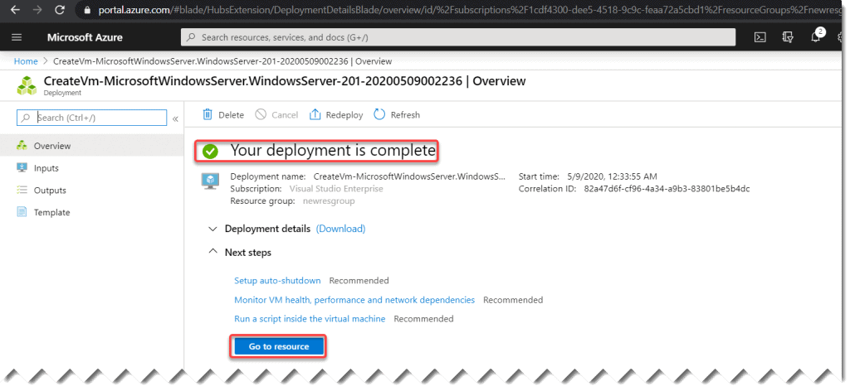

**Step- 5:**Congratulations, Now you have created the VM successfully. Click on the **Connect button** to connect to the VM.

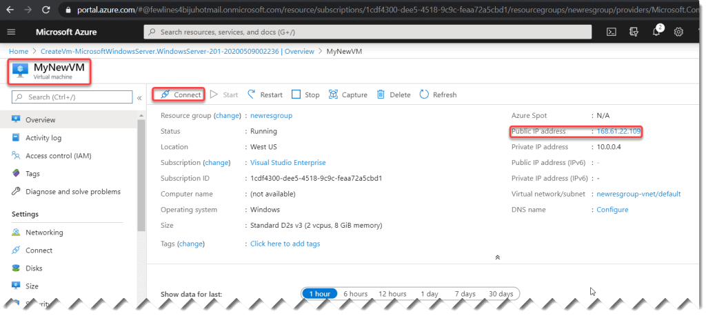

Well, we discussed **How to Create Azure VM (Virtual Machine)**